Sermon: Praying Isaiah 6 - “Use Me”
August 18, 2019 Discussion Notes
Everyone is encouraged to bring a Bible (Phone apps are fine. Study Bibles are better)

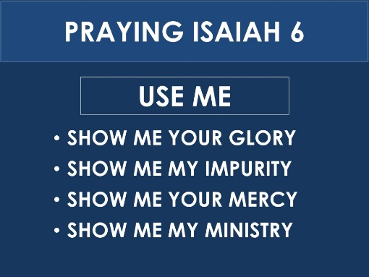
Questions:
- What is a favorite job that you have had in your life? Why did you like it? Share with the group.
- Do you feel that you are working for God in some meaningful ways? How do you feel about your current level of service?
- What do you remember about each of the main points of the sermon? (seen above). What in the sermon challenged you? Do you have any questions to discuss?
- Read John 6:5-14
  - What question did Jesus ask Philip? According to this passage, why did he ask it?
  - Why do you think Jesus sometimes “tests” people like this?
  - If Jesus had the power to multiply loaves and fish, why didn’t he just miraculously put more faith into Philip’s heart?
  - How role did the boy (v. 9) play in the miracle that took place?
  - What role did Andrew play?
  - How do you think the boy and Andrew felt afterward?
  - Have you ever been used by God in some way that accomplished something good? How did it make you feel?
  - What do you have that you could offer to God for His service (even if it’s as small as a few loaves and fish)?
  - Who can you be an “Andrew” to, helping and encouraging them to offer what they have to the Lord?
- Read Luke 5:1-11
  - Why was Peter reluctant to go fishing again? Do you find yourself feeling this way?
  - What was Peter’s initial response to the miracle? Why?
  - How did Jesus reassure Peter?
  - What did Peter and his fellow fisherman do with all the fish at the end of the story? Do you think this was hard for them to do?
  - What do you need to "leave behind" in order be a more useful instrument for God?
  - Reread Isaiah 6:1-8. What parallels do you see between Isaiah’s experience and Peter’s experience?
  - How were Isaiah’s and Peter’s lives changed? How did their God-given experiences accomplish this?
  - To what degree has God worked similarly in your own life? If not too much, are you willing to pray the prayers in the sermon outline?
- Have you taken Class 301 yet? If so, share with the group what you learned about your “SHAPE” (Spiritual gifts, Heart, Abilities, Personality, Experiences).
- Pray for one another’s needs. Ask for God to use you. Also ask Him to use your Life Group and all of BCC.

