Sermon: Praying Scripture
August 25, 2019 Discussion Notes
Everyone is encouraged to bring a Bible (Phone apps are fine. Study Bibles are better)

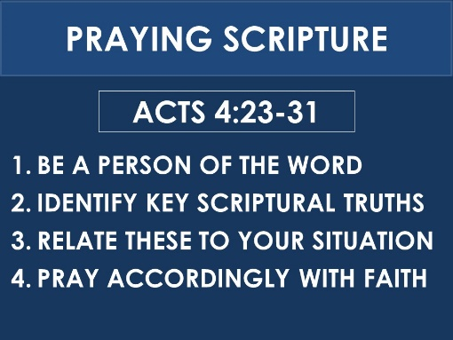
Questions:
- Have you ever experienced a dramatic answer to prayer? What happened? Share with your group.
- How strong is your prayer life? Does prayer come naturally to you or do you find that it takes a lot of effort?
- What do you remember about each of the main points of the sermon? (seen above). What in the sermon challenged you? Do you have any questions to discuss?
- Did anything else stand out to you about the believers’ prayer in Acts 4:24-31?
- Read 2 Samuel 7:12-13, 16. This is a promise that God made to David
  - How did David’s son, Solomon, use this promise as a springboard for prayer at the dedication of the temple? (see 2 Chronicles 6:16-20).
  - What was the result of Solomon’s prayer? (see 2 Chronicles 7:1-3).
  - How do the words (from the angel Gabriel to Mary) in Luke 1:32-33 relate to God’s promise to David?
- Read Deuteronomy 28:58-65
  - In what way(s) did these promises come true for the Israelites?
  - Now read Deuteronomy 30:1-5. If you were an Israelite exile and you read this passage, how do you think you would respond?
  - Now read Nehemiah 1:1-11. Which passage of Scripture does Nehemiah refer to in v. 8? Which passage of Scripture does he refer to in v. 9?
  - In what ways does Nehemiah turn his understanding of these Scriptures into prayer? What are the key points of his prayer?
  - What specific prayer request does Nehemiah bring before the Lord at the end of his prayer? (see v. 11).
  - What was the result of Nehemiah’s prayer? (see Nehemiah 2:4-8 and Nehemiah 6:15)
- Read Jeremiah 29:4-14.
  - This passage contains a well-known verse about God’s good plans for His people. What is the original context of these words? Do you think the Israelites received this message joyfully?
  - Now read Daniel 9:1-3. What did Daniel realize and how did he respond?
  - Read the first part of Daniel’s prayer in verses 4-7. What stands out to you about this prayer?
  - What was required for the promise in Jeremiah 29 to be fulfilled? (see Jeremiah 29:12). In what way does Daniel step up to do his part in fulfilling this requirement?
  - What can we learn from Daniel about how to effectively use Scripture to pray?
  - What was the result of Daniel’s prayer? (see Daniel 1:20-25 and 2 Chronicles 36:21-23)
- Looking back over these passages, how pleased does God seem to be when His people pray the Scriptures?
- What plans can you make to start praying the Scriptures more in your own life?
- Pray for each other’s needs. Try to intentionally use Scripture as you pray together.

